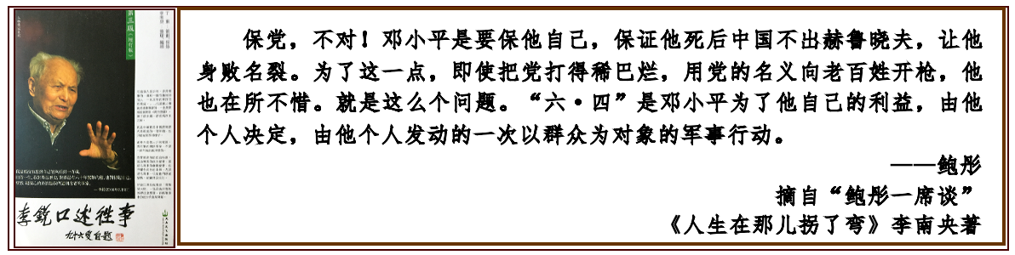
The pictured quotation reads:
“Protecting the Party? No. Deng Xiaoping was protecting himself. He wanted to ensure that, after his death, China would not produce a Khrushchev who might denounce him and destroy his reputation. To achieve that goal, he was willing to do anything—even if it meant tearing the Party apart or ordering troops to fire on ordinary people in the Party’s name.
That is the essence of the issue. The June Fourth crackdown was a military action directed against the people, decided upon by Deng Xiaoping himself and launched in pursuit of his own interests.”
— Bao Tong
An excerpt from “A Conversation with Bao Tong.”
My Life Took a Turn in 1989 by Li Nanyang
Follow-up Report on the “Li Nanyang v. Chinese Customs” Case (142)
— Li Rui’s Diaries Preserved at Hoover, the CCP’s Crimes Engraved in History
June 1, 2026, Li Nanyang
On March 31, the judge signed the Statement of Decision, setting forth his Findings of Fact and Conclusions of Law in the litigation over ownership of Li Rui’s papers.
At first, I assumed the case had come to an end. I did not understand what the judge meant in the final sentence: “Stanford shall submit a proposed judgment approved as to form by all parties within 14 days of the issuance of this order.”
After researching the matter online, I learned that the judge’s signed decision was not the final judgment itself. Rather, it was a statement of the facts he found to be true and the legal conclusions he reached on that basis. The final judgment is a separate document in which the court explicitly rules on the claims, defenses, and requests raised by the parties. Those rulings are based upon the previously issued Findings of Fact and Conclusions of Law.
To ensure that no issue is omitted, the prevailing party is required to submit a proposed judgment for the court’s consideration.
Under the judge’s order, the proposed judgment was initially due on April 14. However, because Zhang Yuzhen’s attorneys requested additional time to consult with the National Library of China—which had substituted for Zhang Yuzhen following her death—the court extended the deadline first to April 18 and later to May 29.
On the final extended deadline, Stanford University and my attorneys, together with counsel for the National Library of China, each submitted their own proposed judgments, along with memoranda explaining why they disagreed with the other side’s reasoning.
The parties agreed that Stanford University’s ownership claim should be granted. They could not, however, agree on how the court should dispose of Zhang Yuzhen’s counterclaims and defenses. For that reason, separate versions were submitted.
Zhang Yuzhen had asserted eleven counterclaims and defenses:
- The counter-defendants infringed copyrights allegedly owned by Zhang Yuzhen in Li Rui’s writings.
- The counter-defendants disclosed Zhang Yuzhen’s private information contained in Li Rui’s papers.
- The counter-defendants intentionally inflicted emotional distress upon Zhang Yuzhen by disclosing her private information.
- The counter-defendants unlawfully appropriated Li Rui’s papers, which Zhang Yuzhen claimed should belong to her.
- Stanford University aided and abetted Li Nanyang in the alleged misappropriation of Li Rui’s papers.
- The counter-defendants conspired to unlawfully appropriate Li Rui’s papers.
- Li Nanyang violated a trust allegedly established by Li Rui.
- Stanford University induced Li Nanyang to violate Li Rui’s trust.
- The counter-defendants conspired to violate Li Rui’s trust.
- The counter-defendants unjustly profited from Li Rui’s papers to Zhang Yuzhen’s detriment.
- This court should enforce the judgment of a Chinese court concerning the disposition of Li Rui’s papers.
Counterclaims 7, 8, and 9 concerned the alleged “Li Rui Trust.” On May 5, 2021, Stanford and I filed a motion to dismiss these claims on the grounds that the purported trust was a personal arrangement and not inheritable. On September 28, 2022, the judge granted the motion.
Such pretrial dismissals are typically entered with prejudice, meaning that the claims may never be refiled. Even so, these matters still need to be included in the final judgment and explicitly resolved. Doing so ensures a clear record and informs any appellate court that those claims are not subject to future appeal or relitigation.
The proposed judgment submitted by Stanford and my attorneys expressly rejected all eleven of Zhang Yuzhen’s counterclaims.
Counsel for the National Library of China, however, argued that after hearing testimony from Zhang Yuzhen’s expert witness during pretrial proceedings, Zhang’s attorneys had already decided not to pursue counterclaims 1, 2, 3, and 10 at trial. Moreover, following Zhang Yuzhen’s death on May 29, 2025, those claims had effectively become moot. Therefore, they argued, these four claims should not be included in the final judgment.
Stanford and my attorneys disagreed. Zhang Yuzhen was still alive at the time of trial, and although these claims were not actively litigated, she never filed a formal motion abandoning them with prejudice before trial. Accordingly, they argued, the judgment should expressly dismiss them.
Based on what I have learned about the American legal system, I understand that rulings included in a final judgment may generally be appealed unless otherwise designated. Matters omitted from the judgment cannot ordinarily be appealed.
For that reason, I can understand why counsel for the National Library of China objected to including counterclaims 2, 3, and 10 in the judgment, since those claims concerned Zhang Yuzhen’s personal interests and could not meaningfully be inherited by the National Library.
What puzzled me was their insistence on excluding counterclaim 1.
After repeatedly reviewing the attorney’s memorandum, I finally understood the reason. If the court expressly dismisses counterclaim 1—the copyright infringement claim—Stanford University may be entitled to seek reimbursement for attorney fees incurred in defending against that allegation. In other words, the National Library of China does not wish to assume liability for those costs and therefore seeks to keep the claim out of the judgment altogether.
California law generally requires appeals to be filed within 30 days of entry of judgment. Extensions may be granted under certain circumstances.
In my view, the National Library of China’s determination to exclude these four claims from the proposed judgment suggests that it intends to appeal certain portions of the case.
I am waiting for the court’s final judgment. I am also waiting to see whether the National Library of China files an appeal. When that time comes, I will continue sharing developments with my friends.
June 4 is approaching. Thirty-seven years have now passed.
Below is an excerpt from my father Li Rui’s diary entry of June 4, 1989.
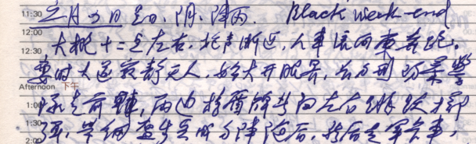
Li Rui’s diaries will endure at the Hoover Institution. The crimes of the Chinese Communist Party will remain forever engraved in the pillar of history.

Above: An excerpt from Li Rui’s Diary.
June 4, 1989 (Sunday)
Cloudy, intermittent rain. Black weekend.
Around midnight, the sound of gunfire drew nearer. Crowds of people and vehicles began running eastward. Suddenly, the avenue became deserted, and I witnessed a scene unlike anything I had ever seen before.
A rectangular formation of riot police led the way. Officers carrying shields on both sides leapt outward and threw grenades. Behind them marched infantry wearing steel helmets in tight formation. Then came military trucks, interspersed with armored vehicles. Soldiers advanced in snake-like formations along both sides of the convoy.
Their submachine guns were held at the ready—sometimes firing diagonally, sometimes toward the ground, sometimes into the air—as they advanced at a steady pace.
Observers stood on balconies lining both sides of the avenue.
Yuzhen and I watched continuously. Later, we brought out a chair and a small stool. A group of young people upstairs crouched behind the balcony railing, shouting slogans in unison through the gaps:
“Fascists!”
“Hooligans!”
“Bandits!”
and other similar cries.

